**Winium Understanding Document:**

Material : <https://www.youtube.com/watch?v=hNsYU7XVWlo>

Link : <https://github.com/2gis/Winium>

Winium Dependency

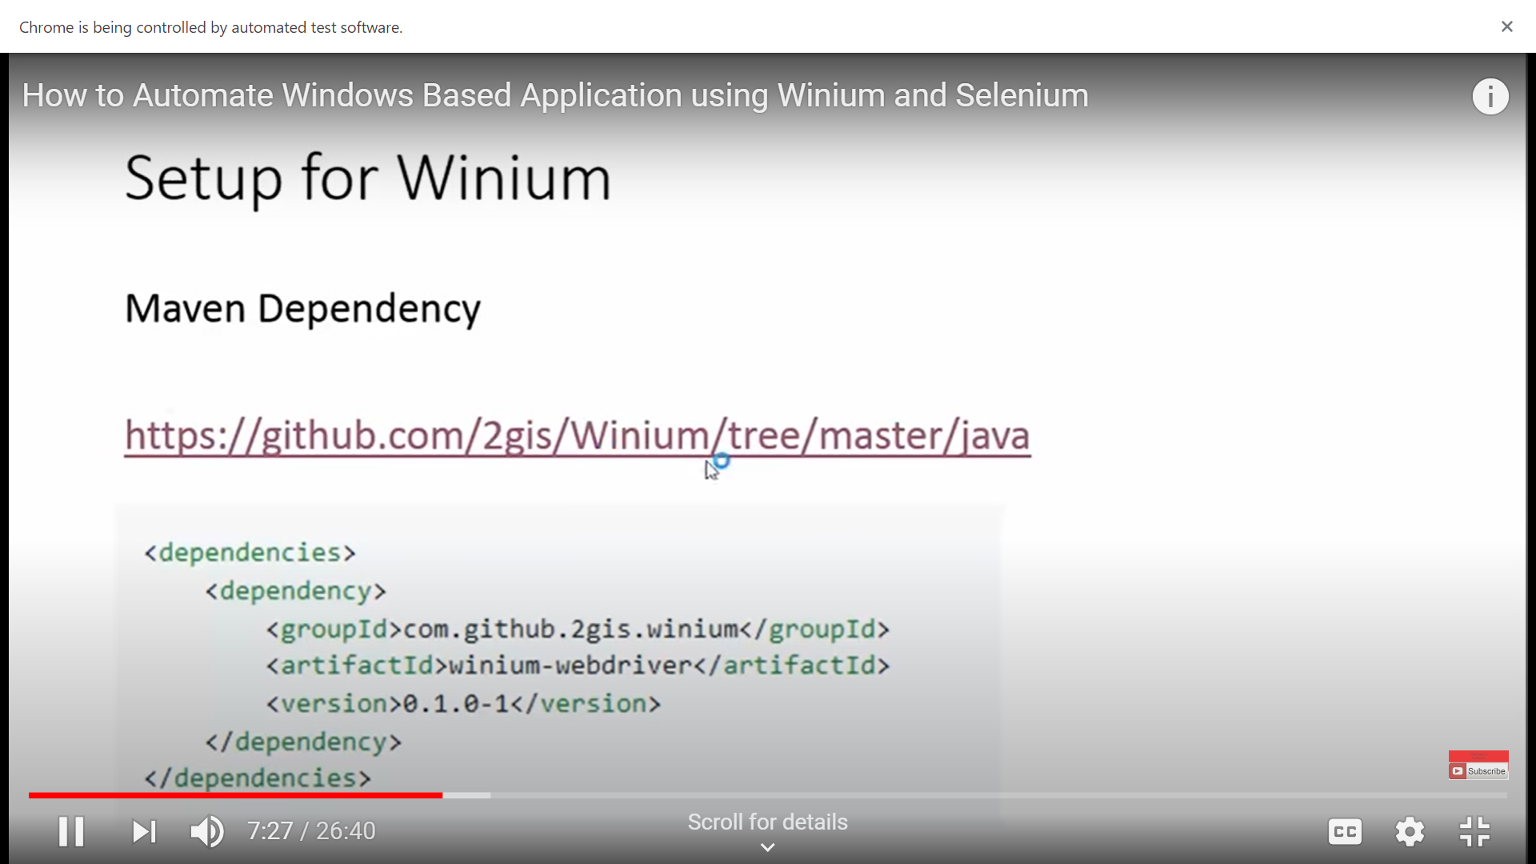

<!-- https://mvnrepository.com/artifact/com.github.2gis.winium/winium-webdriver -->

<dependency>

<groupId>com.github.2gis.winium</groupId>

<artifactId>winium-webdriver</artifactId>

<version>0.1.0-1</version>

</dependency>

<!-- https://mvnrepository.com/artifact/com.github.2gis.winium/winium-elements-desktop -->

<dependency>

<groupId>com.github.2gis.winium</groupId>

<artifactId>winium-elements-desktop</artifactId>

<version>0.2.0-1</version>

</dependency>

Winium Driver ::

<https://github.com/2gis/Winium.Desktop/releases>

**gui-inspect-tool:**

<https://github.com/blackrosezy/gui-inspect-tool>

Step 1: First install the driver ( Just click on .exe to install the driver after downloading)

Step 2: Download one or two gui inspect tool ( example : UISpy or Inspect.exe)

**Note** : UISpy is [declared obsolete](https://msdn.microsoft.com/en-us/library/ms727247(v=vs.110).aspx), Inspect is the recommended replacement.

Step 3: Install .NET Framework 3.5

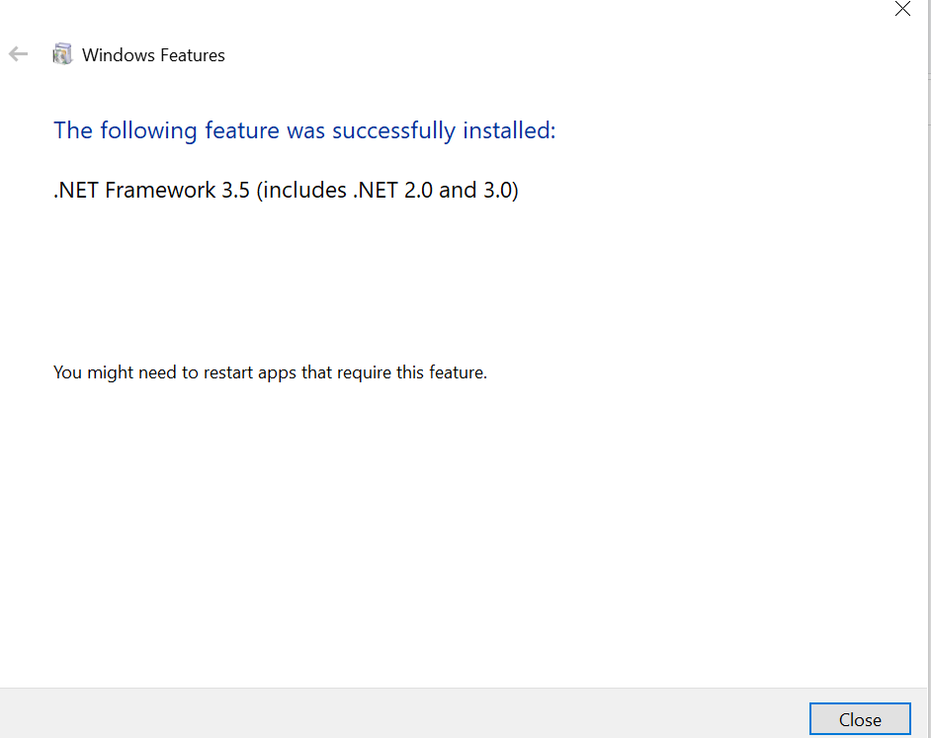

Step 4 : Install windows Kits for windows 10.

Step 5 : Access Inpect from below location.

C:\Program Files (x86)\Windows Kits\10\bin\10.0.19041.0\x64